Conceptual Framework for Data Integration based on DGGS Location v0.8

Geoscience Australia  
RECORD 2021/xx

Joseph G. Bell Geoscience Australia

1. Geoscience Australia (style=Notes, Please delete if GA authors only).
2. List additional author locations here.

Department of Industry, Science, Energy and Resources

Minister for Resources, Water and Northern Australia: The Hon Keith Pitt MP  
Secretary: Mr David Fredericks PSM

Geoscience Australia

Chief Executive Officer: Dr James Johnson  
This paper is published with the permission of the CEO, Geoscience Australia

Geoscience Australia acknowledges the traditional custodians of the country where this work was undertaken. We also acknowledge the support provided by individuals and communities to access the country, especially in remote and rural Australia.



© Commonwealth of Australia (Geoscience Australia) 2020

With the exception of the Commonwealth Coat of Arms and where otherwise noted, this product is provided under a Creative Commons Attribution 4.0 International Licence. (<http://creativecommons.org/licenses/by/4.0/legalcode>)

Geoscience Australia has tried to make the information in this product as accurate as possible. However, it does not guarantee that the information is totally accurate or complete. Therefore, you should not solely rely on this information when making a commercial decision.

Geoscience Australia is committed to providing web accessible content wherever possible. If you are having difficulties with accessing this document please email [clientservices@ga.gov.au](mailto:clientservices@ga.gov.au).

ISSN 2201-702X (PDF)

ISBN 978-1-925xxx-xx-x (PDF)

eCat 140152

Bibliographic reference: Author, J.G. Bell. *Conceptual Framework for Data Integration based on DGGS Location*. Record 2021/xx. Geoscience Australia, Canberra. <http://dx.doi.org/10.11636/Record.2020.0xx>

Version: 2002

Table of Contents

Conceptual Framework for Data Integration based on DGGS Location v0.8 i

1 Abstract 1

2 Introduction 2

2.1 Data Integration (conflation) 2

2.1.1 Definition of data integration 2

2.2 Uses of data integration 2

2.2.1 How data integration improves management 2

3 Principles of Data integration based on location 4

3.1 Everything happens somewhere 4

3.2 Attribution of data to ‘Location’ 4

3.3 Using DGGS cells as well defined and repeatable Locations 5

4 The Geoscience Australia AusPIX DGGS grid 6

4.1 Features of the Geoscience Australia AusPIX DGGS method are: 6

4.2 AusPIX Achievements so far: 6

4.2.1 AusPIX Python module “Engine” 6

4.2.2 Linked Data API 6

4.2.3 Ontology 6

4.2.4 Online DGGS enablement tool 7

4.2.5 Bushfire 2020 burnt area 7

4.2.6 CarSA data 8

4.3 Recently applied solutions using this AusPIX technology 8

4.3.1 Loc-I 8

4.3.2 DEA research 8

4.3.3 Research studies 8

4.3.4 Building first crosswalk Table 8

4.3.5 Bushfire impact assessment 1

4.3.6 2021 Floods 4

4.3.7 Raster Crosswalk Table 5

4.3.8 Potential further uses of the AusPIX framework 7

5 Steps in the AusPIX workflow framework 9

6 Step One – AusPIX DGGS enablement 10

6.1.1 Definition 10

6.1.2 The focus is on the location 10

6.2 The AusPIX format 10

6.2.1 The AusPIX table has these features: 10

6.2.2 Datatypes that can be AusPIX DGGS enabled: 10

6.3 Methods - What AusPIX DGGS enablement does to the data 11

6.3.1 Point Data 11

6.3.2 Line Data 12

6.3.3 Polygon data 13

6.3.4 Raster Data and similar 14

6.3.5 Tools available 15

7 Step Two – The data integration process 16

7.1.1 Definition 16

7.1.2 Benefit 16

7.1.3 Method 16

7.1.4 Structure 16

7.2 How the integration workflow builds the whole picture for that DGGS location 16

7.2.1 Data structured into a common schema 16

7.2.2 To integrate datasets: 17

7.3 Export to other data structures 17

7.4 Tools used 17

7.4.1 Python scripts and modules 17

7.4.2 Future API web interface 17

7.4.3 Manual integration in CSV table 18

7.5 Types of AusPIX integration Tables 18

7.5.1 Data Tables of only feature attributes 18

7.5.2 Index Tables – focus on just feature ID or code 18

7.5.3 Mixed index and feature attributes data 18

7.5.4 Time series Integration Table datasets. 18

8 Step Three – Statistical Analysis 20

8.1.1 Definition 20

8.1.2 Opportunities for statistical analysis 20

8.1.3 Benefits of statistical analysis 20

8.2 What statistics can be derived from the Integration Table? 21

**9 AusPIX as LINKED DATA** 24

9.1.1 Definition 24

9.1.2 Spatially linked data compared with Semantically linked data 24

9.1.3 RDF Triple-stores are built on URL’s 24

9.1.4 Linked Data URI’s in Crosswalk Tables 25

9.1.5 Semantically linked data still needs spatial geometry – trend 25

9.2 Benefits of AusPIX as linked-data 26

9.2.1 Well defined spatial footprint 26

9.2.2 Can consume all data types 26

9.2.3 Cell ID is also a link to the spatial information 26

9.3 Benefits of pre-calculated AusPIX ‘link-sets’ of spatial relationships. 26

9.3.1 Ready to use linked data 26

9.3.2 The Crosswalk building tools already designed and productive 27

9.3.3 Easy to sample to Area of interest 27

9.3.4 Ontologies and vocabs in Linked Data 27

9.3.5 Linked Data API’s 27

9.3.6 Using AusPIX and Linked Data to fetch geometry 27

9.4 Calculation of AusPIX ‘on the fly’ 28

9.5 Can AusPIX spatially-linked data be semantic? 28

**10 AusPIX as MACHINE READABLE MAPS and DATA** 29

10.1 Definition of Machine Readable 29

10.1.1 Common formats for AusPIX data 29

10.1.2 Machine readable Maps 29

10.1.3 Machine readability using spatial relationships (the AusPIX cell) 29

10.2 Methods 30

10.2.1 Online access required 30

10.2.2 Further drill-down 30

10.2.3 Requirements 30

10.2.4 Tools 30

11 VISUALIZATION 31

11.1.1 Definition 31

11.1.2 Application 31

11.1.3 Linked Data API’s 31

11.1.4 Map tool in the AUSPIX enablement API 31

11.1.5 Visualisation tools 31

**12 REGULAR UPDATING & ADDING of AusPIX DATASETS** 32

12.1.1 Definition 32

12.1.2 Everything in one database is impractical 32

12.1.3 Using the AusPIX cell ID as the foreign key to link database tables 32

12.1.4 The AusPIX Update process 32

12.1.5 Reducing complexity 32

12.1.6 Benefits of AusPIX enabled datasets 33

12.1.7 Are cross-database queries a slow process? 33

13 Generation of new and updated AusPIX enabled data 34

13.1.1 Updated versions 34

13.1.2 Keeping old versions 34

13.1.3 Time series 34

13.1.4 Disaster management data 34

13.1.5 Linking data sets to find information for a Location 34

13.1.6 Comparison with RDF triple-stores 34

13.1.7 Tools Required 35

14 Data Drill concept (API) 36

14.1.1 Geoscience eCat 36

15 Conclusion 37

# Abstract

This document outlines a framework for integrating data spatially. The framework includes processes for point, line, polygon and raster data, and outlines methods for integration at defined localities. The framework includes tools for processing for statistical data, index integration, emergency management data, and the presents possibilities for Big Data analysis and Machine Learning.

# Introduction

As the human species, we have collected huge volumes of data. How do we combine and focus on the aspects of that collected data for good management of our people and environment?

This document outlines a framework for integrating data spatially. The AusPIX framework processes conventional spatial features including point, line, polygon, and raster into a well-known referencing grid system named Discrete Global Grid System (DGGS) advocated by OGC (Open Geospatial Consortium) The DGGS is an important component of the Location Index (Loc-I) project, which explores simple to use, but practical and effective methods that spatially express and present the character of specific locations.

These locations are based on DGGS cells. The AusPIX framework gathers the data for each individual location (data integration) and allows it to be queried for totals, apportionment (percent overlap), zonal location queries, statistical summaries, environmental indexes, emergency management information, and to answer specific spatial questions. Outputs can be visualised for decision making purposes. These processes are able to be largely automated and made easy for users.

## Data Integration (conflation)

### Definition of data integration

* bringing together data from diverse sources and schemas into a standard format that allows data analysis, statistics, and visualisations such as graphs, tables and maps
* data integration needs to accept data from points, lines, polygons and diverse raster and grids and other data structures
* data integration needs to bring all data into a manageable framework and workflow system to manage the variety of formats and types
* data integration products should be accessible and flexible whilst being relatively simple

## Uses of data integration

### How data integration improves management

In today’s data rich world, data has to be managed in ways that make it:

* accessible to the end users
* allows relationships between data sets & data types to be quantified and exploited
* provide information across datasets
* provide for higher-level data intelligence and statistics
* allow response in emergency situations (floods, bushfires etc.)

Data integration allows:

Better management of environmental, social, and economic systems by:

* inclusion of data from a wide variety of sources into the analysis
* leverage of the integration tools to quickly bring data sources together
  + use of modern and legacy tools to quickly extract summaries, facts, relationships, and trends from the data. (e.g., SQL, Python Pandas etc)
  + quick data support for disaster response by:
    1. o rapid appraisal of environmental, social, and economic factors in the area
    2. o ability to quickly match new data with existing integrated data (e.g. bushfire example) o through use of precalculated “crosswalk tables”
* conflation (bringing together) of data from richest and most valuable datasets into new high-quality and most up-to-date output datasets. (e.g., conflation of legacy attribute rich geofabric attribution data with modern watercourse spatial line data from LiDAR)

# Principles of Data integration based on location

## Everything happens somewhere

The GIS principle “Everything happens somewhere” defines the approach taken to build the AusPIX Framework for Data Integration by DGGS

* all data has some spatial context to it, even though sometimes it is inferred (in which case we can define the spatial context as an extra step)
* the Loc-I project has this same goal in mind, “define the social, economic and environment data for each DGGS cell (i.e., location)”

## Attribution of data to ‘Location’

* This approach allows a given parcel of land (Location) to be the ‘container’ for any attribute data that belongs to that location.
* the result is an accumulation, or integration, of information about that land parcel, which defines all its character, limitations, and qualities, all sourced from any necessary and available data.
* not only that, but adjacent land-parcels will be treated the same way. The attributes of adjacent locations will sometimes be the same and sometimes very different. (for example, one Location may be in a city with addresses, business data, roads etc, but the adjacent Location might be National Park with vegetation types, species lists and bushwalking trails.)
* zones of Locations can be identified with similar descriptive data as needed
* summarised and statistical results can be displayed as tables and maps
* visualisation will allow mapping to show where these combinations of data change, help us ask questions and initiate special analysis to dig deeper

So, there is a need to consider what to use as a “Location” and what size it should be.

## Using DGGS cells as well defined and repeatable Locations

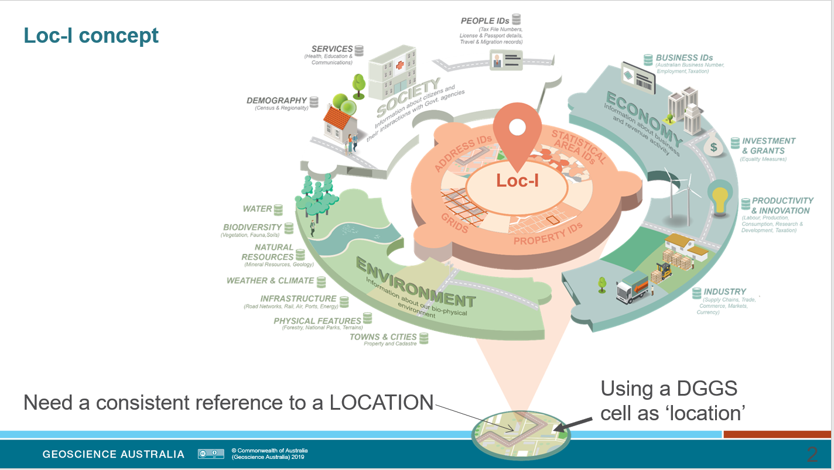

Fig Loc-I Concept diagram showing how the data from diverse sources need to be attributed to a specific location. AusPIX framework uses the DGGS cells as a powerful and useful tool to define equal area locations. The AusPIX DGGS grid is ideal for defining those locations at a variety of sizes in enduring and automated way.

# The Geoscience Australia AusPIX DGGS grid

Over the last three years, under the Loc-I and CarSA projects, GA has developed the AusPIX DGGS technology as a framework concept, and as a workflow tools for data integration by Location.

## Features of the Geoscience Australia AusPIX DGGS method

AusPIX:

* based on a previously well-developed rHealPIX DGGS engine. This python module is actively being developed and maintained today. <https://pypi.org/project/rHEALPixDGGS/>
* has a generally square grid structure
* all cells at a given resolution (size) are totally equal area
* nicely hierarchical, nine child cells fit exactly inside their parent cell

## AusPIX Achievements so far

### Crosswalk Tables

* A major National Crosswalk Table - spatially linking many important geographies
* A similar Raster Crosswalk Table being built to integrate several Rasters important to Emergency Management
* CarSA datasets, DGGS enabled
* Flood extents DGGS enabled
* Bushfire Extents DGGS enabled

More information in the paragraphs below.

### AusPIX Python module “Engine”

* AusPIX DGGS Engine GitHub repository supporting the AusPIX engine. This engine provides all the python code to calculate cells and their many attributes. Supporting scripts have been developed to convert copies of spatial data (eg shapefiles, geojson) into AusPIX DGGS format, and these scripts are stored and shared on GitHub too. Located at <https://github.com/GeoscienceAustralia/AusPIX_DGGS> .
* The engine was recently transformed into a PyPI package for direct import into python at <https://pypi.org/project/rHEALPixDGGS/>

### Linked Data API

* DGGS cells in Linked Data format. A Linked Data API called AusPIX-DGGS-dataset that is live (online) at AWS. This is a ‘virtual’ database in the sense that when any cell is required, the AusPIX Engine calculates everything ‘on-the-fly’ from the engine. This API includes a description of every cell with a ‘landing page’ map and metadata. Every AusPIX cell at all nominal resolutions is accessible as a mapped feature (for visualisation), along with the cell’s essential metadata and alternate machine-readable views eg. <https://fsdf.org.au/dataset/auspix/collections/auspix/items/R78523>
* Source code for this API is in a Geoscience Repository <https://github.com/GeoscienceAustralia/AusPIX-DGGS-dataset>

### Ontology

* AusPIX DGGS Ontology. Part of the Linked Data framework. Ontology work for AusPIX DGGS is on GitHub <https://github.com/GeoscienceAustralia/AusPIX-DGGS-ontology> and as a pyLode format <https://data.gov.au/dataset/ds-ga-dc3f106d-56ec-4a52-8b91-e66dded9e8e2/details?q=>
* Ontology description at: <http://linked.data.gov.au/def/auspix> developed as part of Loc-I project.

### Online DGGS enablement tool

The first step in the AusPIX method is to DGGS enable your data. This tool allows anyone to enable data. Just bring it to this API as a geojson file. <http://ec2-54-206-28-241.ap-southeast-2.compute.amazonaws.com/>

* This is an online API developed by GA in collaboration with CSIRO that allows access to AusPIX DGGS dataset enablement for points, lines and polygons. Anybody can convert their data into AusPIX format without writing any Python code.
* 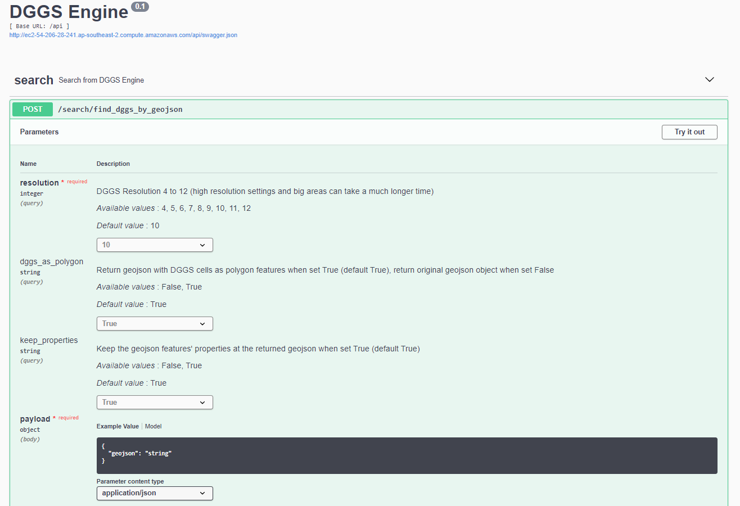

Fig DGGS enablement API that allows the user to AusPIX DGGS enable their own data. This tool will keep all the attributes in your file, break the data into DGGS cells, and return the completed output back to you. With two different data sets (can consist of points, lines or polygons), and once both are DGGS enabled, you can “relate” them on DGGS location ID (eg R7865342378).

### Bushfire 2020 burnt area

* An DGGS table for the 2020 bushfire burnt areas (not official).The AusPIX DGGS information allows the table can be related to all the geographies in the National Crosswalk table, the National Raster Crosswalk table, and DGGS’ed CarSA datasets, using SQL foreign key on the DGGS cell ID.
* This greatly value-adds.
* Note, also cross referenceable with the CarSA DGGS enabled datasets.
* cross referenceable with the National Raster crosswalk which includes land-use data and residential building density as well as other hazard data.

### CarSA data

* CarSA data DGGS enabled
* Applied AusPIX workflows to provide emergency management information and visualisations for 2021 floods
* Applied the AusPIX framework to “Prime Ministers” questions senarios.

## Recently applied solutions using this AusPIX technology

### Loc-I

* As part of the Loc-I project, AusPIX DGGS tools were considered as one possible solution for Loc-I style data integration. Geoscience Australia advanced these methods somewhat separately from semantic and pure RDF methods. Geoscience Australia adopted, and developed Linked Data API’s for important metadata, feature mapping, geometry access, and machine readability.
* CSIRO has adopted AusPIX DGGS into their research work for the Loc-I project
  + feedback from CSIRO was good and they see it as a way to *dynamically* apply Loc-I workflows to otherwise more static methods.

### DEA research

* Three research jobs for DEA to value add to water observations from space data
  1. naming Water Observations from Space water bodies from our legacy spatial data
  2. attribution of which water bodies are on streams and rivers and which are not(using DGGS for data integration.
  3. calculation of irrigated areas against cadastral information – also using DGGS for integration

### Research studies

* Research and development to use AusPIX workflows for attributing LiDAR derived stream vectors with valuable legacy data in Tasmania using DGGS integration.
* Python scripts and workflows to achieve AusPIX DGGS integration and statistical analysis for the AusPIX framework..

### Building first crosswalk Table

The crosswalk tables are precalculated tables that spatially connect the features and data from a variety of data sources.

In this first crosswalk table we have included a number of important geographies and demonstrated the inclusion of some Raster datasets.

This table is live on AWS and available with password access.

An Australia Wide AusPIX DGGS integration table at DGGS level 10 which is 2.4408ha size cells. This dataset represents all of the AusPIX cells for Australia (almost half a billion) along with a crosswalk of several important geographies and grids. As a precalculated resource, it is easy to SQL sample parts of it and download as csv. Fully spatial, can be searched on longitude and latitude or DGGS cells at all levels up to level 10. see eCat <https://ecat.ga.gov.au/geonetwork/srv/eng/catalog.search#/metadata/140149> )

The data set includes:

* + AusPIX DGGS cell
  + URI to cell in linked data
  + cell centroid latitude
  + cell centroid longitude
  + AusPIX cell area
  + SA1 code
  + SA1 polygon area
  + SA2 code
  + SA2 name
  + SA3 code
  + SA3 name
  + ABS Suburb/locality code
  + ABS Suburb /locality name
  + Commonwealth Electoral District code
  + Commonwealth Electoral District name
  + Commonwealth Electoral District area sqkm
  + State Electoral District 2019 code
  + State Electoral District 2019 name
  + State Electoral District 2019 area sqkm
  + LGA code
  + LGA name
  + LGA area sqkm
  + CAPAD ID
  + CAPAD name
  + CAPAD type
  + CADAS GIS area (from data)
  + BoM Grid (using GA ID)
  + BoM Grid area sqkm
  + DAWE Spark grid ID
  + DAWE Spark grid area
  + Postgres geom field for DGGS cell centroid

Note: each of these important geographies are captured in this table along with their features, feature area and their **location relationship to all the other geographies**. Effectively all these geographies are spatially integrated together, and all sorts of analysis and statistics can be used in this integrated environment.

### Bushfire impact assessment

* for Department of industry during the bushfire 2020
* calculated the burnt area in each Suburb/Locality
* demonstrated how flexible the AusPIX framework by calculation for:
  + how much burnt in each State
  + how much CAPAD was burnt in each LGA

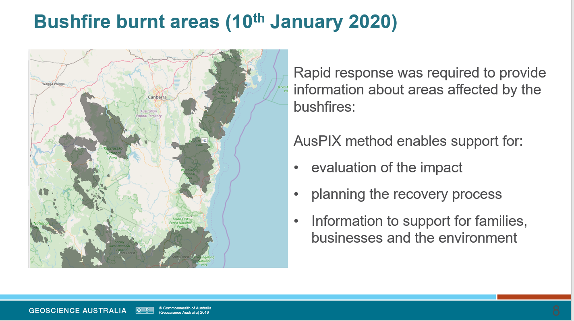

Fig Burnt areas for January 10th, 2020. AusPIX Framework Method can crosswalk this burnt area with data from the National Crosswalk Table and produce many combinations of information very quickly. 10 mins to DGGS enable all the burnt area, 10 mins to query the National Crosswalk Table, and 2 mins for Pandas to calculate totals and crosswalk in several distinct ways.

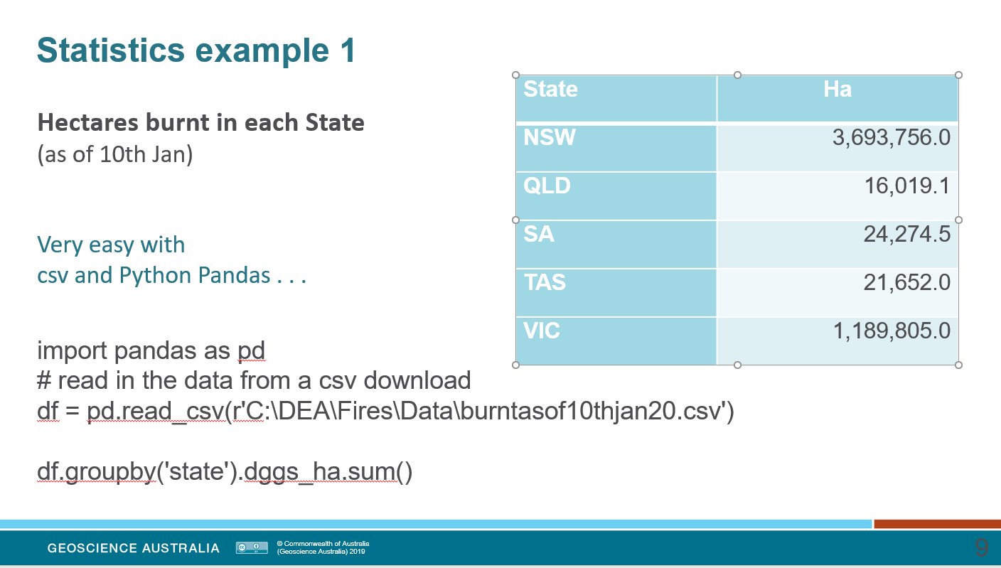

Fig a demonstration of Pandas being utilised to calculate the total are burnt in each State. Pandas take less that 1 minute, to add up the area of each DGGS cell and group-by State. The result comes from just one line of Python Pandas. The same can be done for any other geography for example to summarise on SA2 code change the group-by statement to df.groupby(‘SA_code16’).dggs_ha.sum() and wait less than a minute for a list of all the SA2s in the burnt area with the area burnt for each.

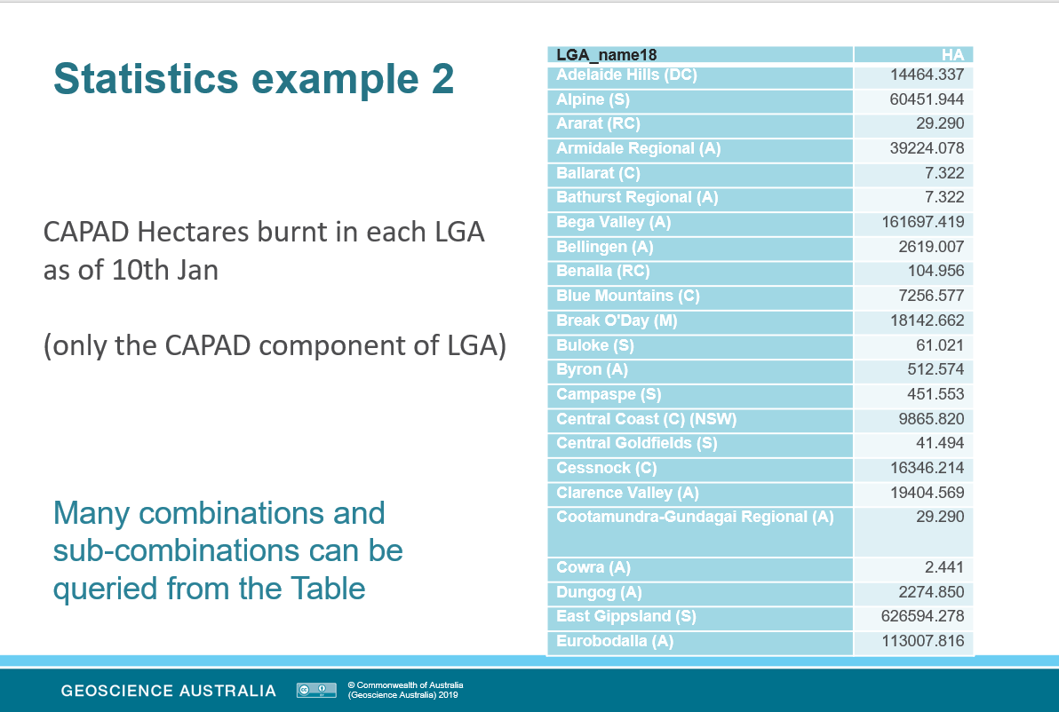

Fig: A more complicated example where we are discovering only how many CAPAD acres are burnt in each Local Government Area. Taken from the same crosswalk data set that was queried on the burnt area DGGD cells. Run time less than one minute in Pandas.

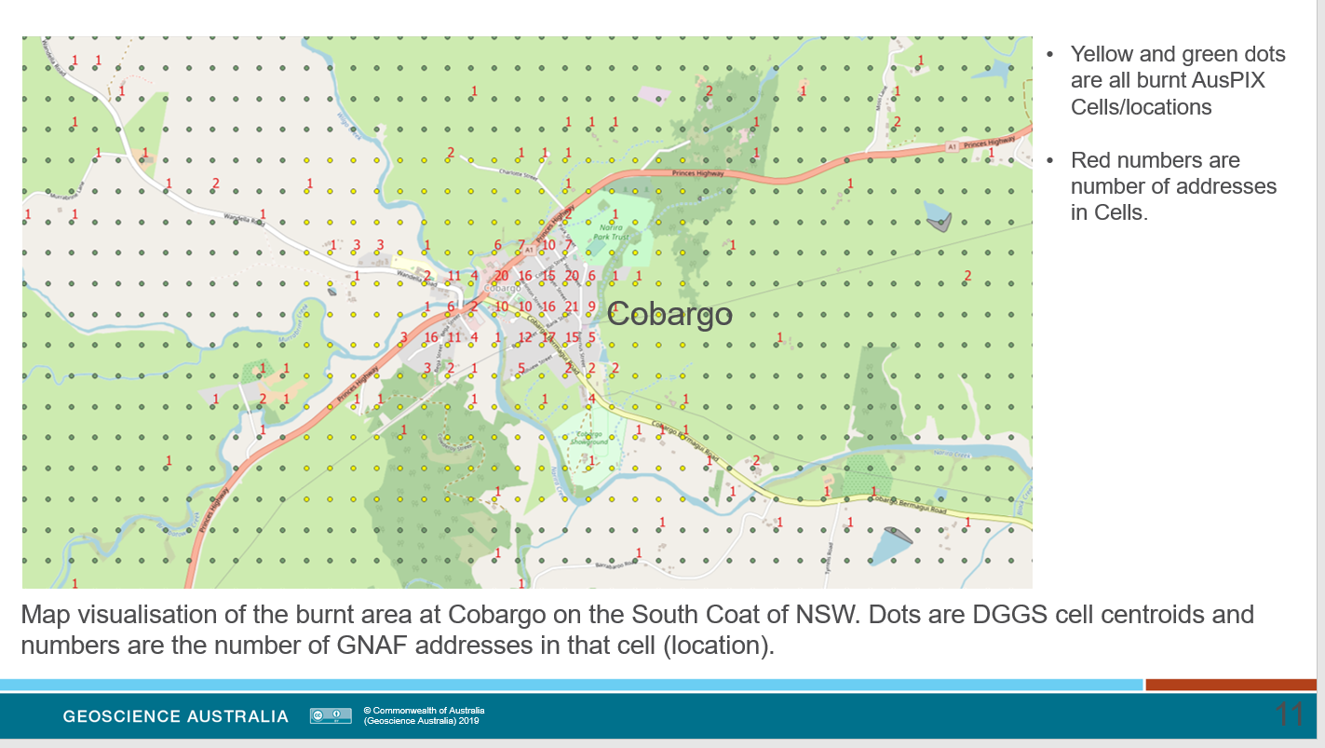

Fig: Close up of the burnt area at Cobargo. The fire went right through the township.

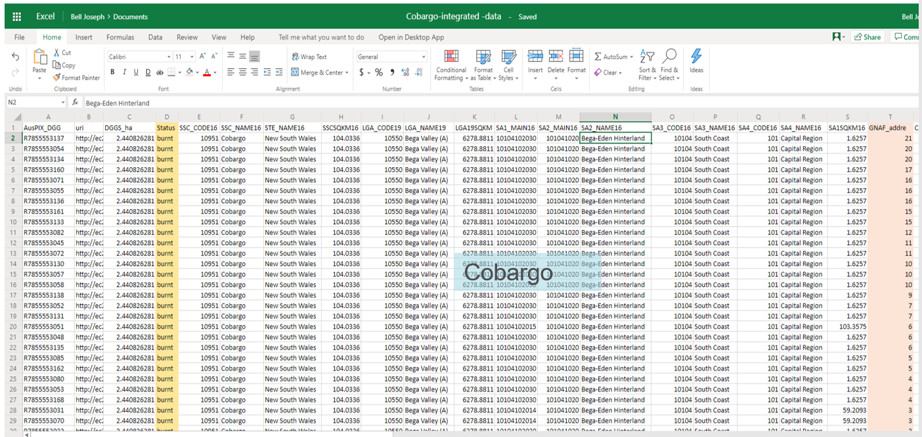

Fig Sample of the Crosswalk integration table that has been joined to a count of GNAF addresses in each cell. This data goes to make up the map image in the map figure above.

### 2021 Floods

* calculated Emergency Facilities close to the flooded and linked to source data and map
* calculated the Area of each land-use flooded from the ACLUMP data
* linked the flooded area to SA2 population statistics from ABS
* demonstrated daily update of figures for reporting purposes

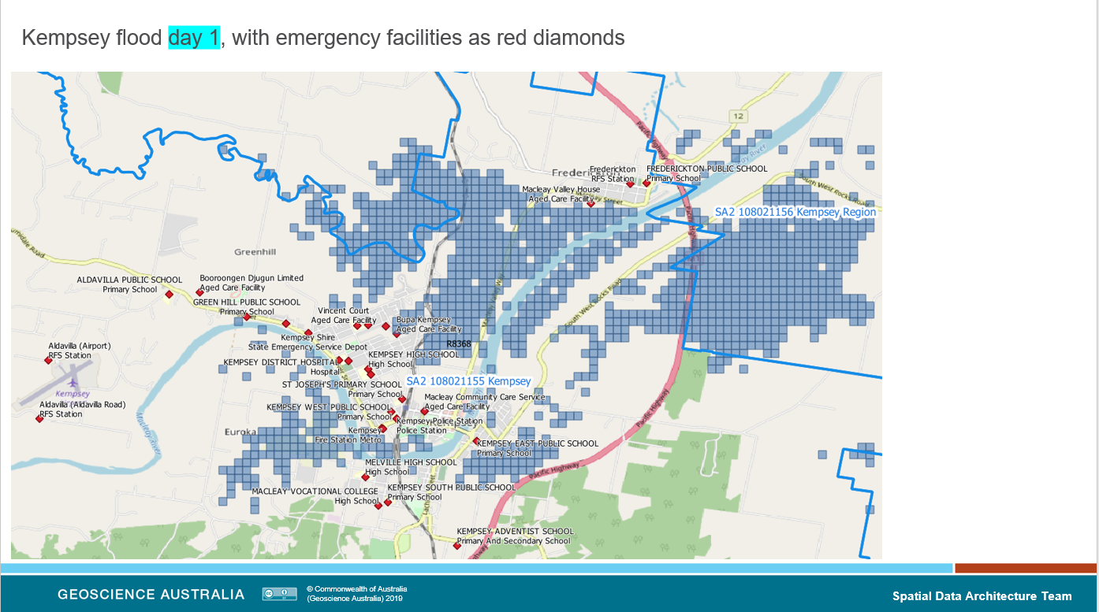

Fig Example of a flood area at Kempsey as AusPIX DGGS cells. Emergency facilities were gathered by finding the SA2s that are touched by the flood, asking for the DGGS cells for those SA2s and relating any Emergency Facilities by matching DGGS cells. Mapped by converting to geojson and displayed in GIS.

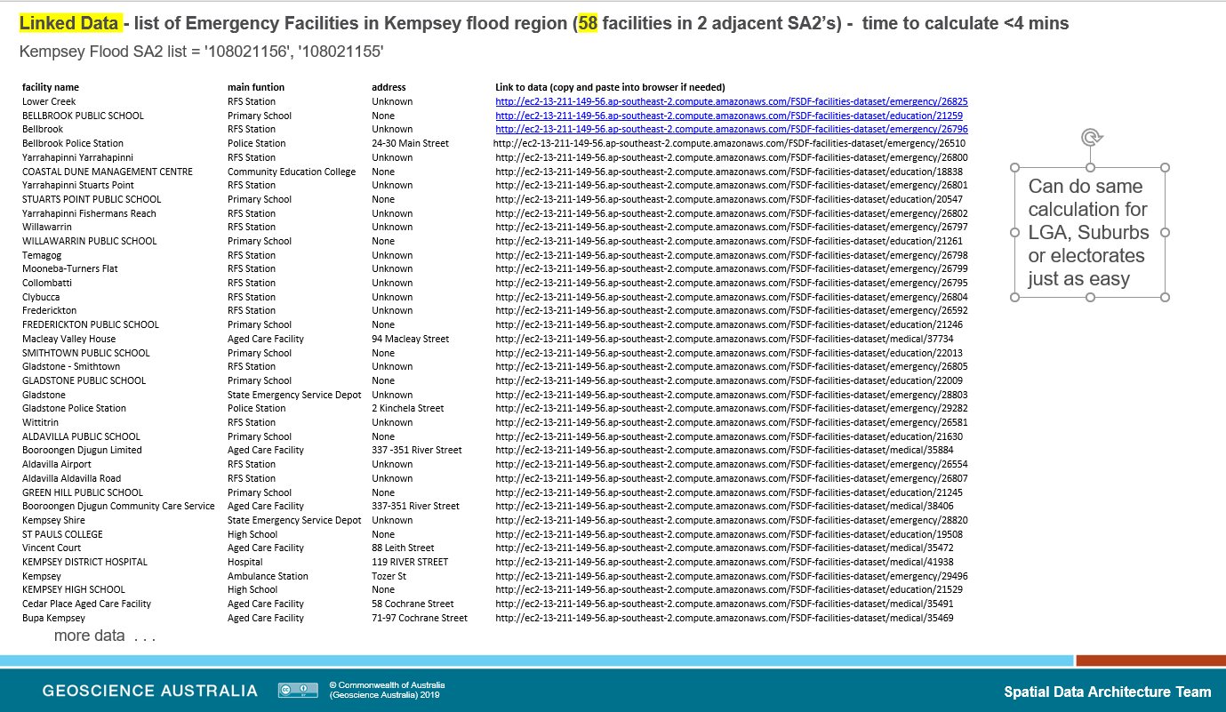

Fig the data for relevant facilities including the hyperlink to Linked Data landing pages and metadata, and vocabs. Example <http://ec2-13-211-149-56.ap-southeast-2.compute.amazonaws.com/FSDF-facilities-dataset/emergency/26825> This is essential information for emergency management.

### Raster Crosswalk Table

This table brings together as set of raster type datasets that crosswalk the data for each Level 10 cell in Australia. This table is focussed on the data rather than on the index or ID for polygons (eg like SA1 code). It displays the data for Emergency Management scenarios and has the follow components:

* Residential density 1km grid
* GNAF count of number of Addresses in the DGGS cell
* cyclone intensity – likely hood of intense cyclone activity
* WofS flood zones – likelihood of flooding from 40years of Observations from Space
* 3 sec Dem – Elevation Model for all Australia
* ACLUMP50 2020 land use raster classification
* quake Hazard Model likelihood of earthquake and intensity

The great thing is that this information is available for cross-walk and analysis with any other DGGS enabled data. It can easily be used as part of a scenario that requires information and statistics from the National Crosswalk Table.

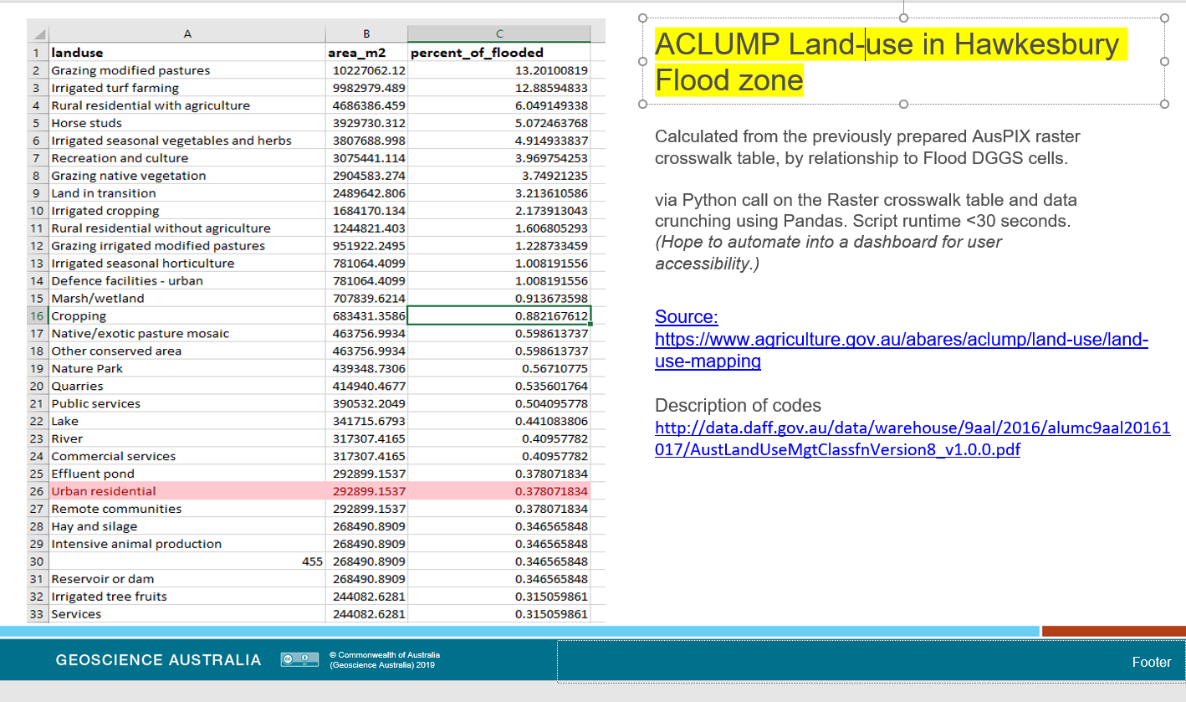

Fig: AusPIX Framework applied to discovering of area of Land-Use flooded 2021 at Hawkesbury River . This information is essential for disaster management.

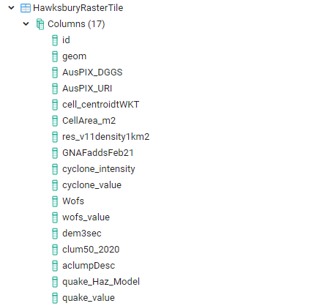

Fig Hawkesbury Raster Crosswalk Tile. PostGIS table example of AusPIX DGGS’ed data tile for the Hawkesbury Flood Zone Table. Accessible online with a read-only password. From this table the GNAF information was related to the Flood zone for estimate of addresses effected by the flood (see below)

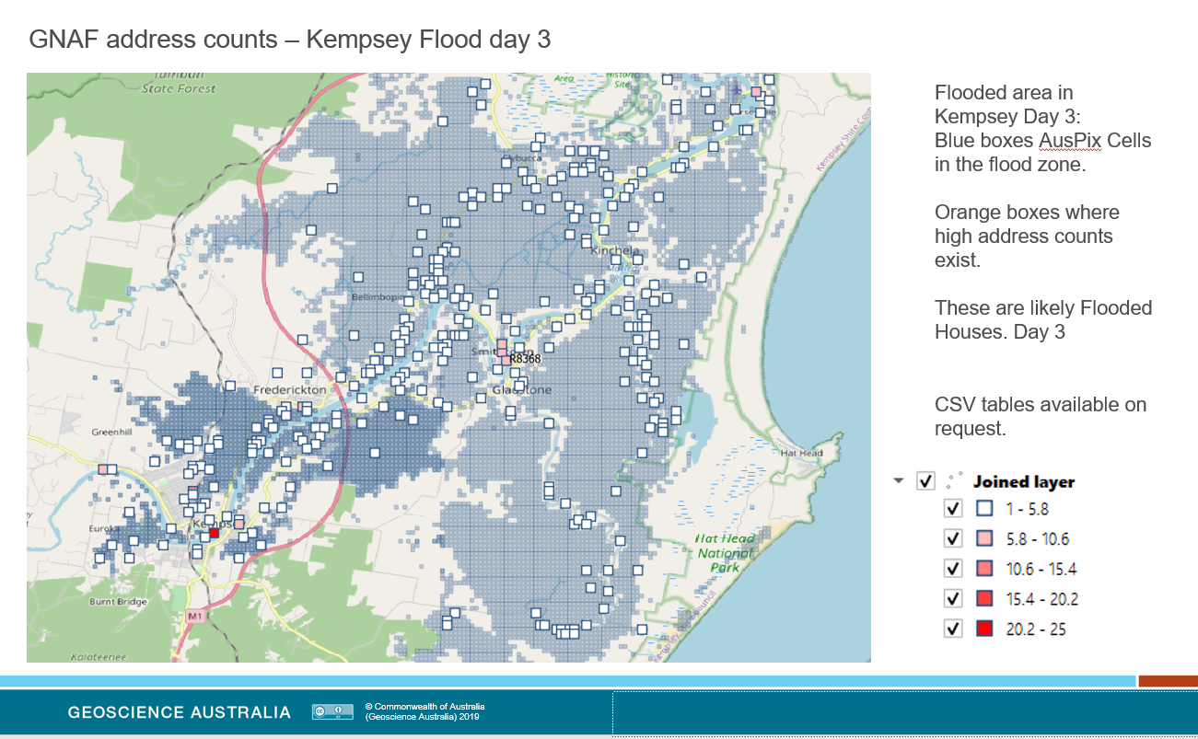

Fig: Flood area for Kempsey Day 3, white and orange boxes locate address locations that are possibly flooded. This is essential information for disaster assessment and resource allocation.

### Potential further uses of the AusPIX framework

* anywhere data needs to integrated and summarised, analysed, reported on, or statistically appraised, (NEXIS AEIP style applications included).
* Departmental data-houses that need to integrate data from a variety of sources together (eg integrate remote area data with unemployment figures and business data) visualise on maps, and make summary statistics for policy making.
* Any Data that has been AusPIX enabled can be included in the analysis.

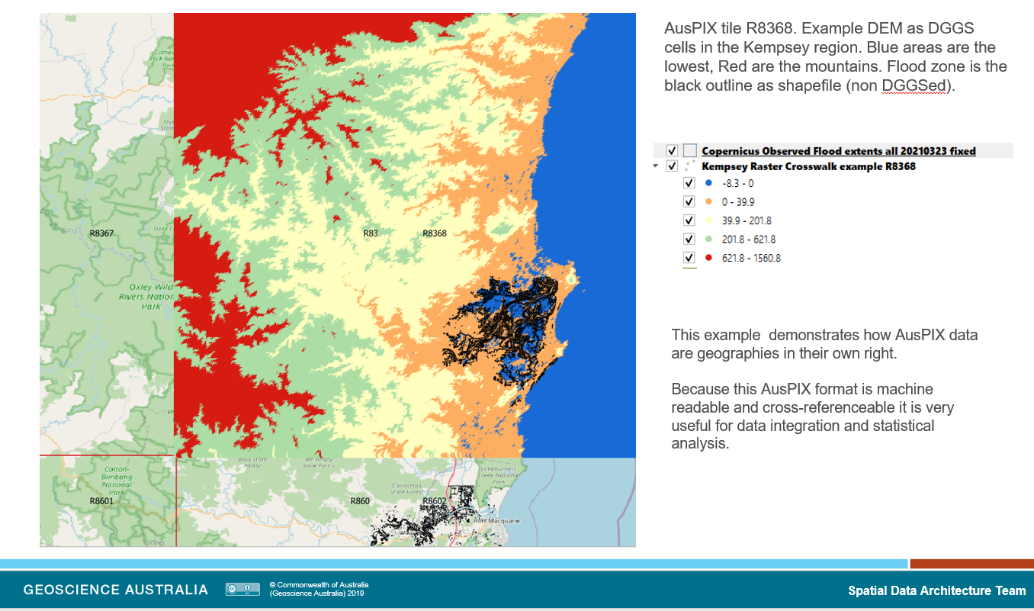

Fig An example of using Digital Elevation Model (DEM) as part for AusPIX DGGS raster analysis.

Although raster data is perhaps not as convenient as polygon spatial data, these AusPIX tables as rasters represent are geographies in their own right. The advantage is that they are machine-readable maps and suitable for quick raster analysis, cross-walking, apportionment, and production of informative outputs.

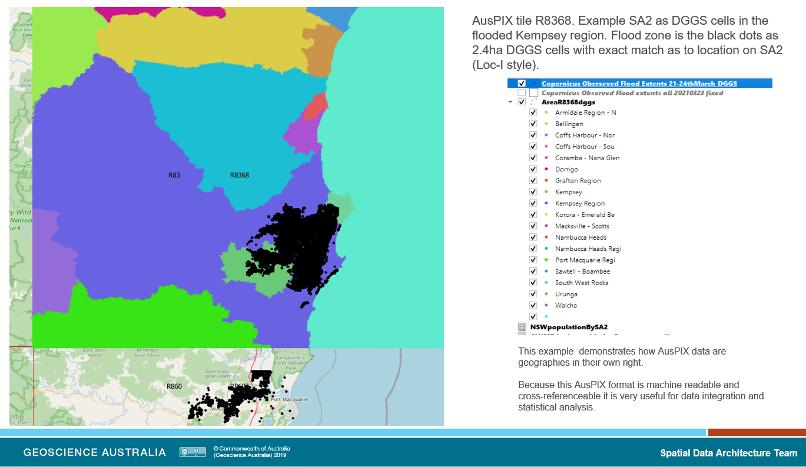

Fig A level 4 DGGS Cell, R8368, visualised in QGIS and coloured on SA2. All the other crosswalk data is included in the attribute table and also available for visualisation like this

# Steps in the AusPIX workflow framework

At present the AusPIX framework can be broken into eight components. The first four are The AusPIX framework methods, the last four are discussion on updating and application to different tasks

1. AusPIX DGGS *enablement* of original source datasets
2. Data integration and crosswalks
3. Statistics, summaries, and analysis (including apportionment)
4. AusPIX as LINKED DATA
5. AusPIX as “machine readable data” and “machine readable maps”
6. Visualisation and graphic outputs
7. Concepts behind updating datasets
8. Use as a “Data Drill” concept

Each of these are discussed in turn (in the next 8 sections)

# Step One – AusPIX DGGS enablement

### Definition

The enablement process converts source data into the AusPIX DGGS cell format. This is a form of raster based on DGGS cells. It involves taking points, lines, polygons, grids or other data structures and transforming them into AusPIX DGGS cells attributed with any of the relevant data. Recent developments in OGC standards include time series specifications into this mix (but AusPIX will be developed in this area)

### The focus is on the location

The AusPIX DGGS grid cell is the focus. The source data is sampled at the cell location, and the appropriate attributes are transferred to the AusPIX cell. Attributes remain identified as belonging to the source data. Each AusPIX cell is usually represented as a row in a table. The data attributes become the columns of a simple but powerful interrelated table. One SA1 for example may be represented as 100 or more cells, each represented as a row in the table.

## The AusPIX format

### The AusPIX table has these features:

* each row generally represents one AusPIX cell (eg R7523481)
* the first column is usually the DGGS cells ID.
* note: the spatial data (location) is now also represented by the AusPIX cell ID which represents a unique cell and a unique location
* often the XY, WGS84 location of the cell centroid, and the cell area are included for processing convenience.
* columns are added to the table from the source data attributes, as required. Essentially each group of columns represents a geographic dataset and indicates which feature in that geography is located in that cell. The first National Crosswalk table has 32 columns.
* Note: this process goes to the feature level ID and the feature data level as required

### Datatypes that can be AusPIX DGGS enabled:

* points
* lines
* polygons
* rasters - images
* grids – including 3D grids like DEA grids
* time series data

All these data types can all be represented as data attributed to AusPIX DGGS cells. Some are more complex than others, and some need consideration of the desired outcomes before proceeding.

Python scripts and web API’s have been built for this enablement level. Scripts and APIs automate this work.

## Methods - What AusPIX DGGS enablement does to the data

AusPIX DGGS enablement resamples data from the source data (shapefile, geojson, data-structure etc) into the AusPIX DGGS cells.

### Point Data

* for point data, the AusPIX engine quickly determines which AusPIX cell the point is in. The Lat Long in WGS84 is sent to the engine and the engine returns the Cell at the resolution asked for.
* An online App is available (developed by CSIRO to GA specifications) that will DGGS enable points, lines and polygons sent to it as geojson spatial files. . (see <http://ec2-54-206-28-241.ap-southeast-2.compute.amazonaws.com/>
* Generally, the DGGS cell ID becomes the first column of the dataset. Extra columns are added to include the attributes from the source data as needed (e.g. a Place-name or address, polygon area).
* The AusPIX cell is now attributed with the relevant data from the source data and the source data has been AusPIX enabled.
* other data types are very similar.

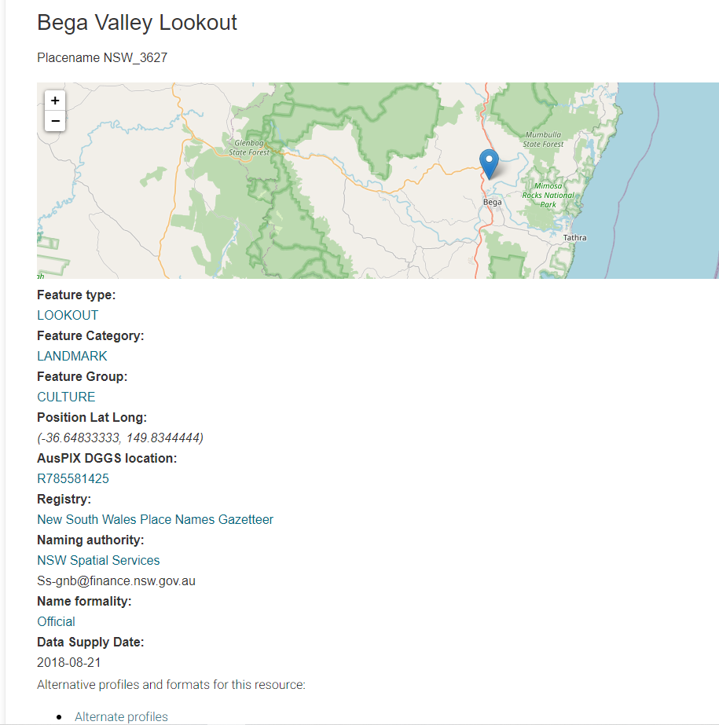

Fig A point feature from the Placenames linked data API including metadata that shows the latitude and longitude of that point. The “AusPIX DGGS” location in the description specifies which DGGS cell that point is located with-in. This cell is also hyperlinked to view the DGGS cell landing page itself.

### Line Data

* Lines are DGGS enabled by considering the line as a series of interconnected points, beginning at one end of the line and finishing at the other. The DGGS engine is asked for the cell that each point belongs to. As unique cells are found they are attributed with the line data (e.g. ‘Canberra Avenue’). Presently the script development includes a “densification” function to ensure the line is represented by a continuous string of cells along the line.

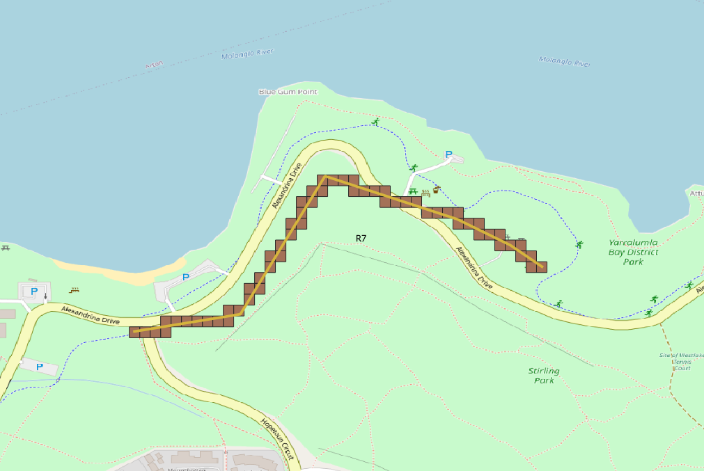

Fig: an example random line feature in orange and the AusPIX Cells that represent that line in brown. Roads and rivers look like this when AusPIX DGGS’ed.

### Polygon data

* polygons can have many AusPIX cells within. Having many cells within a polygon is preferred, because, as other datasets are later overlaid into the AusPIX cell grid, there will be different combinations of attributes from the different source datasets. Small cells can fit into tight corners and small spaces to properly represent the combination of data from many overlapping data sources.

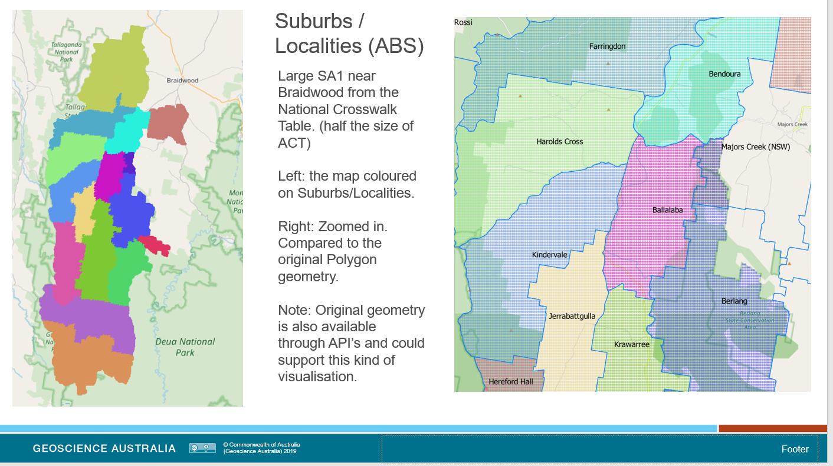

Fig Comparison of AusPIX DGGS’ed data and the original shapefile, or geojson file

### Raster Data and similar

* Raster data can be sampled by asking for the raster value at the centroid of the AusPIX cell. This may miss some raster values and consideration of this may be required to see if it is fit for purpose. This method is similar to geophysics sampling and interpolation. Higher resolution cells may give a better representation of the data – ie sample a higher resolution and somehow resolve to the operating resolution.
* This worked well for the 2021 Flood data and gave a good idea of the Land-use affected by the flood.
* Gridded data has been treated as small polygons, often containing many AusPIX cells.
* Data-cube data. This is a 3D stack of data, usually with time as the vertical dimension. Data can be AusPIX enabled by taking the spatial latitude and longitudes of the cube as a grid and sampling to the AusPIX grid. There may be several AusPIX cells in each grid depending on the resolution of the AusPIX cells and the resolution of the Data-cube grid. Attribution to the AusPIX cell will depend on the workflow requirements for the extraction of data-cube data and its use with other datasets. AusPIX resolution will depend on desired outcomes and the types of data it will be integrated with. OGC specification for DGGS now allows for time series data.

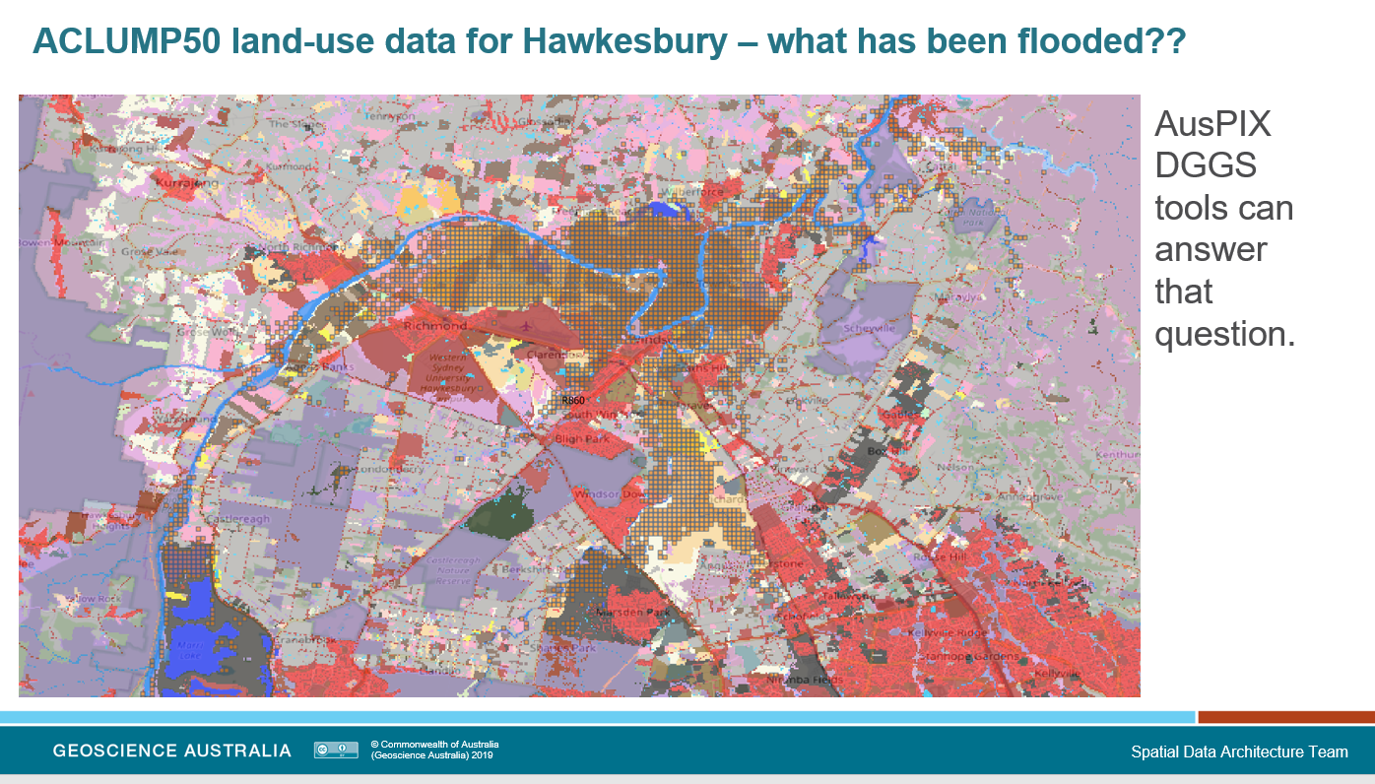

ACLUMP50 land-use data that was sampled to investigate the impact of the 2021 Floods on the Hawkesbury River in Western Sydney

### Tools available

* Python Scripts, as data handling tools, that use the AusPIX DGGS Engine and the source data to transform information into the table AusPIX format A GitHub repository that is progressively populated is located at <https://github.com/GeoscienceAustralia/AusPIX-crosswalk-code>
* AusPIX DGGS enablement API’s – use the web to DGGS enable your data (link <http://ec2-54-206-28-241.ap-southeast-2.compute.amazonaws.com/> ) This API allows the user to bring their data to an online resource as a geojson file, and have it automatically transformed into an AusPIX enabled dataset.
* Pre-calculated databases. For example, the Australia wide AusPIX dataset (at AusPIX level 10) has enabled a series of important geographies and grids. (link eCat <https://ecat.ga.gov.au/geonetwork/srv/eng/catalog.search#/metadata/140149> ).This dataset can be SQL queried and downloaded as required (ask for access). It can be further linked on AusPIX ID to any other DGGS enabled data. This table pre-calculates a large section of the common AusPIX workflow.
* A pre-calculated raster crosswalk table is being processed including several rasters commonly linked to emergency response(mentioned above) including Land-use and Residential Density.

# Step Two – The data integration process

### Definition

The integration workflow connects together our previously “AusPIX enabled” datasets. The AusPIX DGGS cells defines the spatial location where the data integration occurs.

Connection and integration may simply be along a row or more of an “integration table”, or by using the DGGS as a foreign key to integrate other data DGGS tables.

### Benefit

The benefit of this integration process is that data from all sources is now in a common schema and highly spatially linked together. This provides very data rich, integrated set.

### Method

Integration involves taking an AusPIX cell, and any data already attributed to it, and matching the cell ID to any other AusPIX enabled data. Because data rows with the same ID belong to the same location, they can be freely conflated. This way many source datasets can be integrated or conflated into a single AusPIX dataset instance.

Alternatively, datasets can be conflated using relational database methods, i.e. matching data on AusPIX cell ID. That is, across-tables integration based on DGGS cell ID as the foreign key.

### Structure

Integration Tables are columns of data conflated to the DGGS cell locality. There is one or more rows for each AusPIX cell, and the columns represent pieces of data relevant to the spatial extent of that cell (at AusPIX level 10 this is 2.44ha).

Now that the data and properties are attributed to the AusPIX DGGS cell, there is standardised ability for statistical enquiry and data investigation.

## How the integration workflow builds the whole picture for that DGGS location

### Data structured into a common schema

* each row generally represents a single AusPIX cell, the ID for which is in one of the first columns
* other columns represent the attribute data for the cell from any of the other datasets
* (alternately data can be in separate database tables with the AusPIX Cell ID as a foreign key)
* Table example: the Australia Crosswalk Data Table - links 8 or 9 Datasets by AusPIX DGGS cell location
* Note these datasets can be considered as a type of “big-data” with the ‘National Crosswalk Data Table’ being half a billion AusPIX cells (at DGGS level 10) of very concentrated and spatially-linked, URI linked, and data-relationship driven information.

### To integrate datasets:

* AusPIX enable two or more datasets
* match data on AusPIX cell ID to extend the data attribute holding for the AusPIX cell.

## Export to other data structures

The data Integration Table is very suitable for export into other data structures. As tables of linked data, they are now in the form of a “spatially enabled” csv file, these tables have proven to be easily transformed into different data structures. For example:

* shapefiles – DGGS cells and attribution are routinely exported to shapefile for visualisation.
* geojson files – for machine readability and data transfer, as well as visualisation
* SQL databases – routinely ported to Postgres, for query and provision users as an online resource.
* Triple Store – csv files are normally routinely ported to RDF triples (we have done some early work on this.) Before porting to the Triple Store CSIRO Build the datasets in a Postgres database – however they had difficulty with the spatial component (points, lines, polygons) and have built a separate geometry server to visualise and map geometries. Note AusPIX carries all geometry in the DGGS cells ID so it doesn’t need the complication of separate servers etc. The Linked Data APIs can also return geometry for mapping.
* Note: An AusPIX DGGS version of a triple store would include the spatial component the simple AusPIX DGGS cell ID (e.g. R7854632).

## Tools used

### Python scripts and modules

* Python scripts have been developed to facilitate data integration for particular tasks. These scripts work though the AusPIX enabled data to find matching DGGS cells in other datasets fed into it. Data is then concatenated on the AusPIX cell level to build a more complete picture of that location. Python scripts can take advantage of modern data tools like Pandas, NumPy, Scikit-learn and data structures like Dask (DEA structures).
* for advanced data work, Python can be used for machine-learning, and high-level statistics over these big, data-rich tables. Integration (crosswalk) tables are very rich, higher level big-data!

### Future API web interface

* in the future we expecting to develop a more automated and standardised method (to be provided as an API). The CSIRO work done recently for DGGS enabling datasets did not involve this data-integration layer.

### Manual integration in CSV table

* Many Data Mangers routinely manipulate data using csv tables perhaps using MS Excel.
* the format of the AusPIX DGGS integration table is very easily exported as csv and Excel files
* *It is important to note that the AusPIX DGGS cell ID, which is usually in the first column, is actually the spatial reference for that row of data attributes. This means the AusPIX DGGS framework supports spatial referencing within csv and Excel files. All analysis on the csv can retain the essential spatial information and can also allow for the future mapping and visualisation (by using relatively simple tools). However, to export to a map, we need to call on the DGGS ‘engine’ or the DGGS API, for the spatial data for each cell.*

## Types of AusPIX integration Tables

The are several types of AusPIX data integration tables that have been put into use so far. Here is a brief summary:

### Data Tables of only feature attributes

**Tables that focus purely on data** like area, population, vegetation type, number of businesses etc. – dataset feature properties and attributes. An example is the National Raster Crosswalk table where the cells are attributed with the value of rasters at the centroid of the cell.

### Index Tables – focus on just feature ID or code

**Tables that focus on codes, ID’s, and links**. These are linking datasets that expose the ID’s of data sources in an integrated and spatially linked way. For example, the Meshblock code, the SA1 code, LGA name, Electoral District Name, the Environment SpARK grid code, a code for the BoM grid, or a CAPAD polygon name/ID. These tables open up the AusPIX linked data door for all the data attached to any of those codes, perhaps tens or hundreds of data columns for each. So, this is a type of hyper-linking service. The user can now link any data that uses those IDs, Codes and indexes together with the others onto the AusPIX cell ID. Very much a linked-data workflow. This method exposes the feature level ID code, but not necessarily further attribute data in the first instance. This method has been applied by using the SA1 code to link to population data for those SA1 areas.

### Mixed index and feature attributes data

Depending on use case, **mixtures of data and index-based linkages** can be used. For example, the Australian AusPIX Crosswalk Integration Table has a mixture than includes both ID and feature data linked across many geographies. In this dataset, not only the polygon ID was retained, but also polygon name, and the polygon area where applicable.

### Time series Integration Table datasets.

These Tables express how a single dataset changes over time. For example, an ABS SA1 time series Integration Table would have all the 5-year versions of the SA geography. For each location (expressed as a DGGS cell) a complete history of the SA1 designation is now expressed in the Integration table. Users can query the table to see how AusPIX DGGS cells have changed their SA1 attribution through time. Connected to SA statistical data, this can lead to significant time series analysis.

Note: All this happens in an open repeatable and demonstrable way. Anyone can read an Integration Table like a csv table and see what the data is saying. With time series analysis, it shows how a locality has changed (through time) as information across just one row of the table. Statistics tools can be used over the whole table to automate and summarise statistical outputs.

# Step Three – Statistical Analysis

### Definition

Now that we have integrated data (from our second framework step), information discovery and cross-walking for higher-level statistics can begin.

Data from all sources is now in a common schema and highly spatially linked together.

### Opportunities for statistical analysis

There are some fantastic big-data, spatial analysis, and statistical applications that now can used on our AusPIX integration tables. How these are applied depends on requirements, but there are many opportunities to answer a great variety of needs.

### Benefits of statistical analysis

The benefit of applying statistical analysis to the Integration Table is that it reveals details and relationships between combinations of the source datasets; allowing the user to gather information from those higher integrated levels; and without the need for the user to be a GIS expert. In the integration table, any combination of source data is equally as accessible as any other, and equally open to statistical investigation. No need to recode and re-run for the new focus geography! Simply change the focus of the tools. 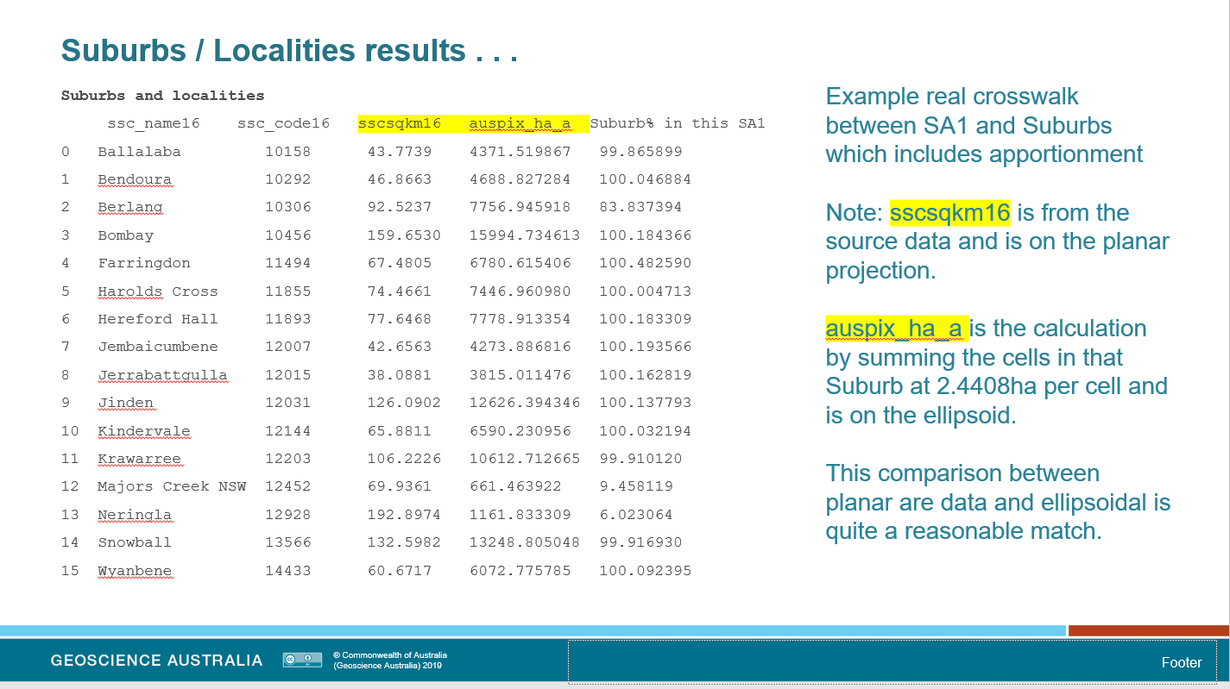

Fig: Crosswalk beween SA1 and Suburb/Localities (ABS) that includes approtionment. Some suburbs are only partially in this SA1. Why are the figures not exactly 100%? We are compapring planar and elipsoidal area calculations, which are calculated estimates themselves.

## What statistics can be derived from the Integration Table?

* Simple counts, lengths, and area calculations
* Overlap, including the actual spatial location of that overlap ie, geographic apportionment
* Note: one geography can be measured against all other geographies in an AusPIX integration table, because it is all related to the AusPIX cell. If data exists in one geography it can be easily summarised in any other geography (best to have the source data in its highest resolution).
* Python Pandas queries have been demonstrated to be very quick at providing statistics from large tables. Pandas provides statistics like percentiles, standard deviation, and other data description methods, as well as simple sums, max, min etc. Scipy provides specialised support for mathematics, science and engineering.
* Higher spatial classification based on data attributes or combinations of attributes from different geographies - this is standard raster analysis for capability or vulnerability, and tools like python numpy and others provide considerable advantage toward extracting useful information.
* Machine learning, AI and deep learning algorithms
* Principle component analysis (perfect for these crosswalk tables of many types of data) – can highlight the data that has the greatest influence if data is appropriate for this.
* Big data analysis of various sorts (e.g. the AusPIX level 10 database is big-data consisting of 430 million cells, cross-walked through 10 geographies. As more geographies are added, the data becomes even richer and able to support deeper information/knowledge analysis).
* Also, other csv and Excel manipulations and data extraction methods that Data Managers commonly practice (after all, the AusPIX integration output is basically a table of spatially connected geographies, with the locality defined as the AusPIX cell ID)

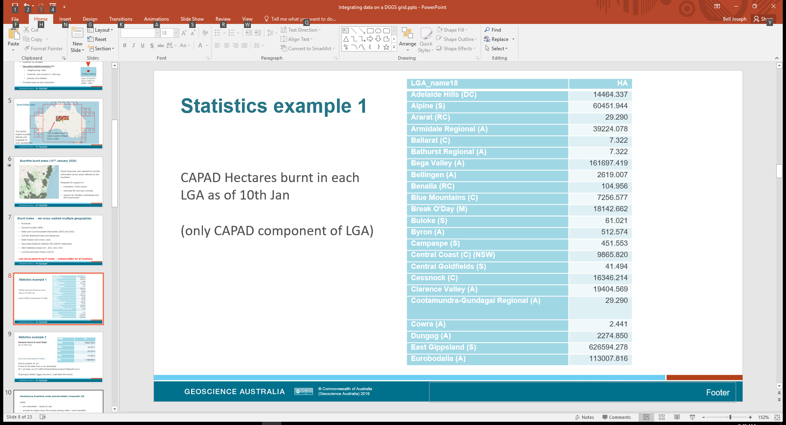

Fig example of simple-basic statistics - but very useful when managing resource allocation after disasters (unofficial data).

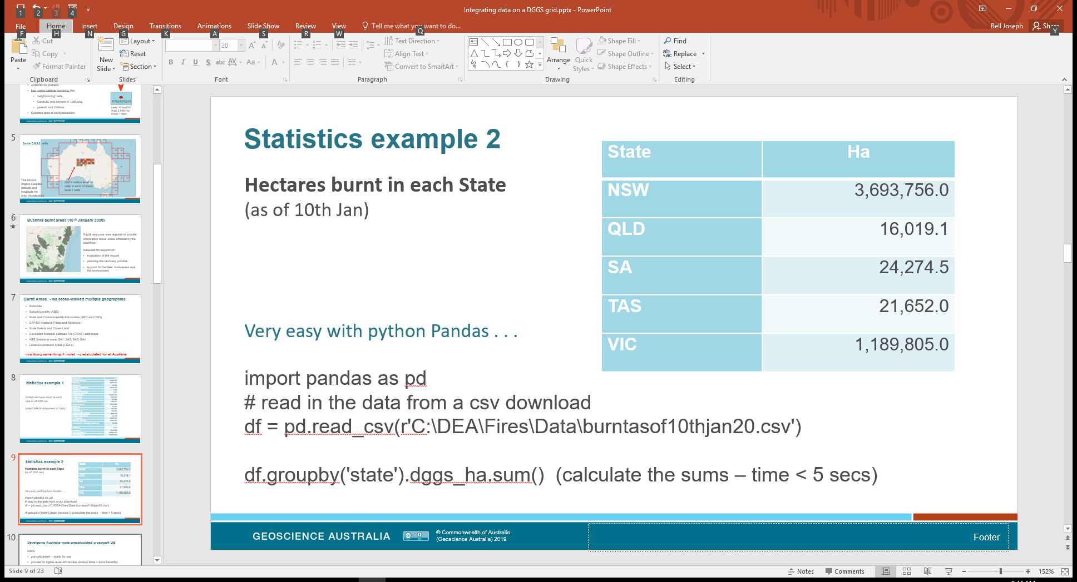

Fig some unofficial statistics pulled together using a powerful Python Module called Pandas

#### Tools for data summaries and statistics

Because the integration table is basically a spatially enabled CSV table, it can be imported by almost every statistical application.

* Python Pandas – very quick modules that are commonly used in data analysis. Pandas has many statistical functions and is written for Python in the C language (fast).
* standard statistical toolbox applications like R – data is in a suitable format already
* straight forward CSV table manipulation applied in a spreadsheet (common)
* Sci-Py big-data tools
* Python machine learning and deep learning tools
* others

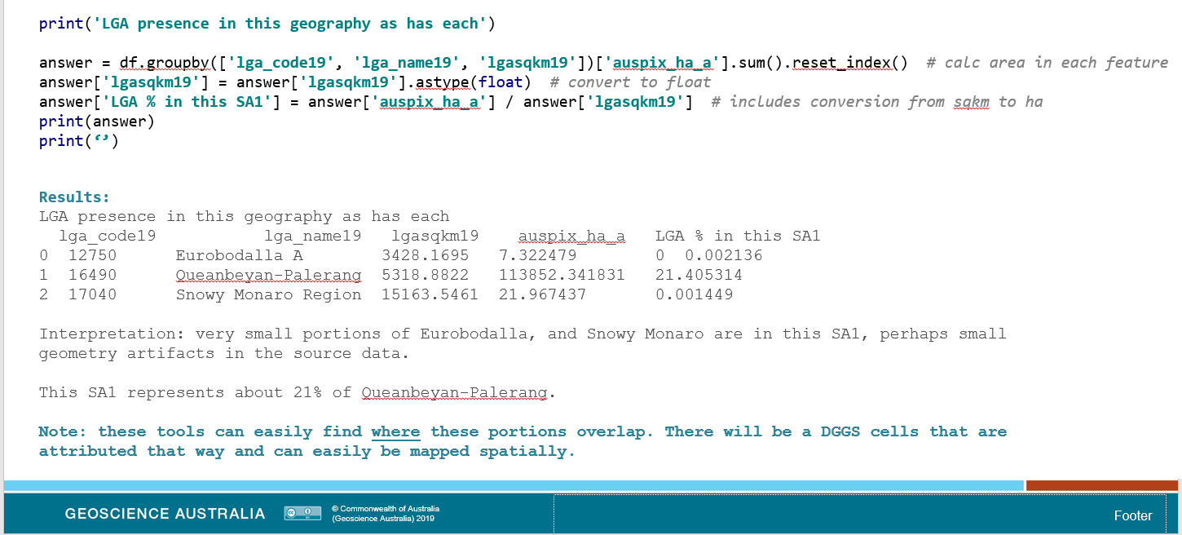

Fig: Python script to derive statistics from an “Area of Interest” download from the National Crosswalk Table. Using a Pandas data frame, and some Pandas statements, this apportionment calculation figures which LGA (Local Government Areas) intersect with our SA1 and by how much. Two of the LGA’s seem to be tiny overlaps at the edges. Visualization conforms this.

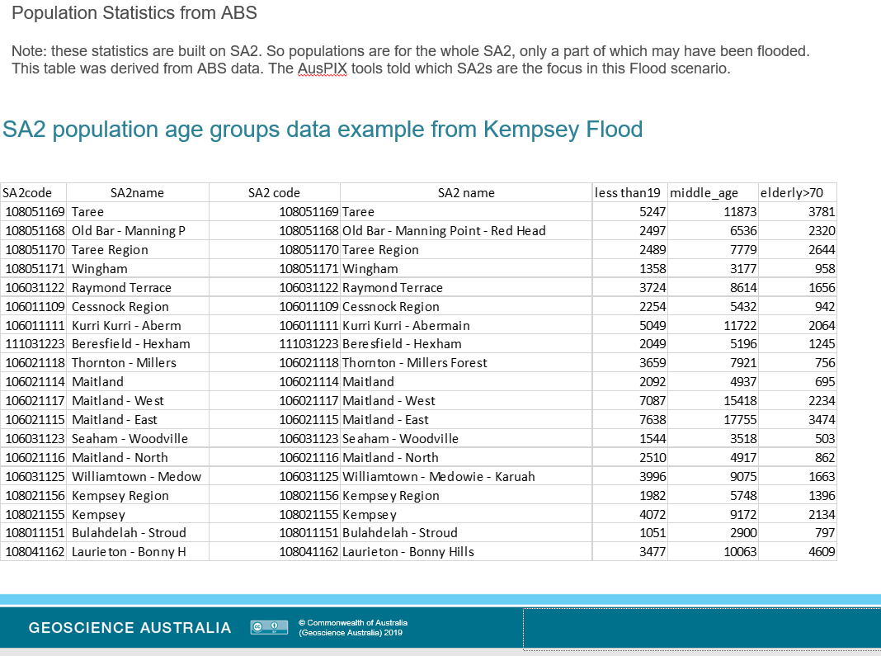

Fig: Set of SA2’s that touched the Kempsey Flood, discovered using python and pandas. These SA2’s have been joined to ABS population data to understand the age groups affected. Very useful for disaster management. [Could also be done on SA1].

# **AusPIX as LINKED DATA**

### Definition

Linked-data is structured data, which is interlinked with other data, so it becomes more useful though queries. AusPIX enabled data is inherently linked-data because it links data to the spatial location construct of the AusPIX DGGS cell. Any datasets that have been AusPIX enabled, join this system, and are already enabled as spatially linked data and are able to provide information for statistical queries.

### Spatially linked data compared with Semantically linked data

AusPIX linked data is a spatial ‘linked data’ technology (c.f. semantically linked). AusPIX presents the cells as well-defined equal-area locations. Data is now linked on its existence at that location. This focus on location provides a defined and repeatable method for linking data. APIs can easily be developed around AusPIX cells to describe that location.

Semantically linked data, as the name suggests, is associative and contextual descriptions (semantics) that allow queries to use pattern matching and reasoning to link data. There is no focus on a particular aspect of the data, rather it is up to the skill of the user (or the API?) to navigate through the possibilities, build a query suitable for the question being asked, and though some development and testing, to finally give an answer (not so consistently repeatable)

### RDF Triple-stores are built on URL’s

Note: Semantic RDF triple-store data should ideally consist only of URL’s. This use of URL’s makes the data paths machine readable. So ideally, only data that has a URL resource built for it should be included in the triple-store. Some data (e.g. AusPIX cells, ABS SA series, Place-names, etc) do have Linked-data API’s built for them and so are resolvable by URL. Many others (LGA, Suburb/Localities??, SpARK grid) may not have a URL resolvable API built for them at this stage (but can be built).

Keep in mind though, the raw attribution data for points, lines, polygons etc, is not always URL resolvable. An exception is a simple dataset like Place-names, here the URL will link through to the raw data exposing the place name, coordinates, and metadata.

SA1 data is different. There are great many datasets built on SA1 code. Knowing the SA1 code for a particular AusPIX DGGS cell allows all that data to be attached to it. This requires finding the data and joining the attributes on SA1 code.

Most commonly the URL many only resolve as far as feature ID in a dataset, and its metadata. Utilities can be built to extend the reach to feature attributes. This can be done by having, say, population statistics available in a suitable repository and allow connection to fetch data.

This is in case for SA1/SA2 data. Probably Hundreds of data sets are built on SA1/SA2 data and so the underlying raw attribute data will not normally be available directly. In these cases, a further step is required to somehow introduce the raw data (eg. population and category ABS 2016) to the data analysis.

### Linked Data URI’s in Crosswalk Tables

Another dimension is added to DGGS crosswalk tables if the URIs for features are included. These URIs point to Linked data APIs and provide essential metadata.

Where available, URI’s to data features in Linked Data API have been included in crosswalk tables. This adds all the benefits of the Linked Data API’s to the Crosswalk, bringing metadata like the publisher of the data (i.e. authority), the spatial geometry, and the vocab descriptions of the fields.

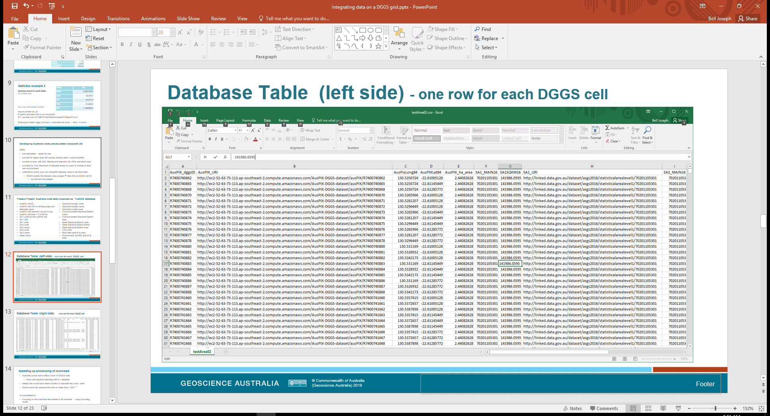

Figure: Linked Data URI’s as part of an data integration table – these are for the AusPIX cell, and the SA1 data in the table – both link to linked-data API’s available online. This linked-data links to more information about the same data set – Maps, vocabs and alternate views.

### Semantically linked data still needs spatial geometry – trend

There is a trend at the moment to bring spatial characteristics into semantic databases (RDF triple-stores). This is in response to the need for more spatially defined outcomes. Technology that has been developed for this are things like geometry servers and the geosparql query language. To have spatially defined out comes ensures that outcomes are talking about the right ‘Sydney’ and not the one in Canada. Geometry is also essential for determining percentage overlap of the different geographies (apportionment) for semantic systems.

Difficulties of the pure sematic approach include:

* trying to represent points (eg addresses) semantically as being in which part of some polygon overlap, ie does the point occur in the overlap of two polygons or not
* or even defining which part of one polygon that another polygon overlaps. (ie the spatial data for the overlap. Pure sematic queries will only indicate that they do overlap. The geometry for features needs added and geospaql queries written.

These things can often be solved with pure spatial analysis, using ESRI, QGIS or PostGIS, but this does add considerable complexity to end-user queries. This type of Semantic linked data requires very skilled users, complex workflows, and to a large extent, provision of datasets and tools that will only answer limited pre-conceived queries.

Note: using the AusPIX framework solves these problems in a different and much simpler way:

* cell ID’s (eg R 765482334) identifies location, so if the cell ID for a point feature is in the set of cell IDs that represent a polygon, then that point is inside the polygon.
* similarly, knowing the cells that represent each of two polygons, comparison of the cell IDs will quickly show the overlap (ie where the cells are the same)
* we can also count the cells and determine the area of overlap
* and of course, by mapping the cells the overlap can be visualised

## Benefits of AusPIX as linked-data

### Well defined spatial footprint

AusPIX linked data technology has several proven advantages for linked-data. AusPIX linked data benefits from well-defined spatial locations (cells) that provide a solid basis, and allow us to link, integrate, statistically query, and visualise the data and outputs. Calculated by the python DGGS engine, these cells are enduring and highly repeatable.

### Can consume all data types

AusPIX linked data benefits from the proven ability to link points, lines, polygons and various grids and other data structures (eg DEA data structure).

### Cell ID is also a link to the spatial information

Perhaps the biggest benefit is the inclusion of spatial information in the form of a simple cell ID, very suitable for CSV and other table formats. This ‘spatially enables’ even the CSV files and provides the essential location ‘key’ to allow linking to any other AusPIX enabled data. This ‘spatial key’ also provides an essential ‘foreign key’ for any relational database work where DGGS enabled data may be in separate tables.

## Benefits of pre-calculated AusPIX ‘link-sets’ of spatial relationships.

### Ready to use linked data

As described in the section on data integration crosswalk tables (Step 2), while taking some processing power to build, actually provide ‘linked-data’ in a ready-to-use format. There is no need to further process the table to determine relationship, or to link it to geometry servers. It serves as a ready-made, data rich resource, that API’s can utilise to answer user queries, or as a csv crosswalk table to those that prefer CSV.

These crosswalk tables also provide a “data drill” function by providing the combination of features at the centroid of the cell. A simple python app can covert an XY location the user selects dynamically on a map and return the list of DGGS enabled feature that exist at that point.

### The Crosswalk building tools already designed and productive

Large pre-processed AusPIX link sets are not easy to build. An example is the original National Crosswalk table which has half a billion locations as DGGS cells. It requires GIS and Python algorithms and plenty of processing power to generate, especially at the Australia wide scale. Initially, source datasets need to be checked for geometry quality, then AusPIX enabled and subsequently integrated using the purpose built AusPIX algorithms that have been developed.

The big advantage is that, once complete, the data is ready to sample for your area of interest, and for further crosswalk for the information required.

### Easy to sample to Area of interest

The benefit is, that once built, these pre-calculated integration tables are ready for use. In fact, these tables can be sub-divided and separated to use for smaller areas quite easily. For example, the Australia Wide AusPIX DGGS level 10 table can easily be SQL queried (manually or API) to dump the information for a particular area of interest (e.g., an SA1 or cyclone land-fall). It can then be related to any new dataset (e.g., flood outline) to quickly and efficiently to provide an integrated picture. This was demonstrated during the 2021 floods.

### Authority, Ontologies and vocabs in the AusPIX framework

Ontologies, data authority tagging, and vocabs are important to linked-data systems. They define the data and describe the attributes in standardised systems. They enable potential conflation of similar datasets by helping determine if data attributes are equivalent or partly equivalent. Ontologies and vocabs are essential for understanding the data, helping prevent misapplication of attributes, and essential for updating or extending to new versions.

### Linked Data API’s

Several important datasets have Linked Data API’s built for them. This includes Placenames, AusPIX DGGS cells, the Sites, Samples and Surveys series, the ABS SA series, Geofabric and others. Hopefully, these will all be catalogued for easy discovery.

These Linked-Data API’s include links to their ontologies (?) and vocabs, as well as presenting landing pages (with maps), and alternate views of that piece of data (as triples, csv, json etc). These features have application in both human readable and machine-readable technologies.

The AusPIX Framework seeks to include these Linked-Data API by providing URL links for every spatial feature mentioned in the crosswalk table.

### Using AusPIX and Linked Data to fetch geometry

Linked data APIs include the source geometry of features. We can easily connect a DGGS cell, to the existence of a particular feature (from the crosswalk table) then use the URI for that feature to fetch the machine-readable geometry, ready for mapping or other spatial investigation as required.

### 250k maps

For 250k Maps we could have the 250k extents DGGS enabled. Then is a simple workflow to fetch all the relevant features from their Linked Data APIs (with geometry and attributes). We could select the data types we want on our map(e.g. roads and National Parks). Having this list if features we can easily construct a map. When the feature data is updated in the API, the new features will come through to the map product.

## Calculation of AusPIX ‘on the fly’

Similar algorithms can be used to calculate AusPIX crosswalks on the fly. This would be suitable for smaller areas rather than for all of Australia. Some work has been done with this, for the work on Stream attribution in Tasmania, and the Crosswalk between irrigated areas and Cadastre in Queensland.

## Can AusPIX spatially-linked data be semantic?

Yes definitely, sematic technology is very flexible and AusPIX DGGS enabled data can be expressed semantically if required.

A benefit of using AusPIX enabled data semantically is that cell ID also carries the spatial information, so no need for geometry server support. The AusPIX cell makes an excellent ‘subject’ in the RDF (resource description framework) triple.

A triple is ‘subject – predicate – object’ in RDF. By making the AusPIX cell the subject of the triple, the attribute names (predicates) and data (objects) can express the AusPIX integration table in an RDF format.

So, the AusPIX integration table is reformat-able into semantic RDF. We can say this AusPIX cell “R765188” is in SA1_2016, “800756432”. Extra triples can be added for each attribute column of the AusPIX cell. In the Australia wide Integration Table there are 32 columns, and so about 32 triples would be needed for each of the half billion AusPIX cells, producing a triple-store of about 15 billion rows. This is quite a large triple store. However in proper RDF everything has a URI (link) or a literal (data), and so for full RDF application all data needs to be in a “repository” and built around URI connection.

Example of a “repository” URI endpoint for place-names is <https://fsdf.org.au/dataset/placenames/collections/placenames/items/NSW_3627>

or for AusPIX DGGS Cells:

<https://fsdf.org.au/dataset/auspix/collections/auspix/items/R78523>

(These are examples from Geoscience Australia Linked Data API’s)

Additional triples might be needed depending on the query requirements and speed objectives required on the triple-store. The user would need to decide which format is most suitable, integration table or integration RDF triple-store, depending on need.

If all data is crammed into one Triple-store:

* they become very large quickly
* cost more than PostGIS databases
* need a dedicated team to maintain the Triple Store
* cannot be a distributed data system where each custodian looks after their own data in separate places

# **AusPIX as MACHINE READABLE MAPS and DATA**

## Definition of Machine Readable

****Machine-readable format means a structured format that can automatically be read and processed by a computer such as comma-separated values (CSV), Javascript Object Notation (JSON), or Extensible Markup Language (XML).**** <https://www.lawinsider.com/dictionary/machine-readable-format>

### Common formats for AusPIX data

* csv
* database tables
* relational databases
* python modules to convert between CSV, JSON, XML etc (easy)

### Machine readable Maps

AusPIX Crosswalk Tables are essentially machine-readable maps. They represent the geographies as DGGS grid cells. When displayed on a map, each geography can be visualised as a raster image to the user. With AusPIX DGGS it is also possible to walk between the resolutions to represent at the preferred level if needed. Note: if the source polygon is preferred, the hyperlink in our table can be used to collect the spatial data from the Linked Data API, and to allow us to represent the polygon that way.

Note: In this way AusPIX is not trying to be another format for geographies, but rather a tool for integrating and analysing combination of data sources.

The point about *MACHINE READABLE MAPS* cannot be too highly stressed. Automation, linked data and analysis for disaster management all require machine readable maps. This allows significant automation, repeatability, speed and standardisation of processes. The need for standardisation was highlighted in the 2021 floods when the Satellite mapped data, as shapefiles, was structured differently every day and included some data processing errors.

### Machine readability using spatial relationships (the AusPIX cell)

* the AusPIX cell ID is a powerful tool that defines the data as belonging to a (cell) location, preventing confusion about eg which ‘Sydney’ the data refers to.
* the AusPIX cell ID provides a well-defined object key to allow linking data through a series of data elements to pull it all together as an outcome.
* machine reading methods have the opportunity to leverage the AusPIX cell ID to link and join data. This cell ID in unique and enduring, defining a location, and not subject to sematic uncertainties of which ‘Sydney’ it refers to.

## Methods

### Online access required

Machine readability requires generally online access to suitable resources from a specialised API.

Machine read queries are automated algorithms that are built to access and return data from known resources, with the aim of conflating this information for the user.

The AusPIX technology has the advantage of the cell ID that describes the location. Cell ID provides an enduring location and a unique resource identifier, removing much uncertainty and fudging when employing machine readability. Machine queries can pull in information quickly and automatically [assuming that all the resources it wants to reach are maintained and available].

Machine readability is built into APIs and other systems that link to appropriate resources. Integration tables perform a unique opportunity for machine reading API, being highly available (online) and having a known schema. They can be accessed and searched (mainly with SQL) to find the correct data.

### Further drill-down

Results come back to the API and that could result in further reads from other accessible dataset. For example, say a machine query finds the area-of-interest has a SA1 polygon with the code 8065436; the API can go on to query another database for population and economic data about that polygon, conflating a complete set of information back to the user for that area-of-interest.

### Requirements

Note: for data to be useful for this method, it must be available, accessible, maintained, and authorised to some level of useability. It must have features that allow machine algorithms to access it.

### Tools

The AusPIX APIs, Integration tables, ontologies, and vocabs collectively provide for machine readability and discovery. Much work is required to build and maintain a machine-readable ecosystem.

AusPIX contributes greatly to requirements for machine reading automation, by linking geographies directly in the table, making it a simple read across the table row for links to features in other datasets.

# VISUALIZATION

### Definition

Visualization is presenting the data in formats that allows easy visual presentation of the underlying data. This might be a graph, chart, map or any other choice available. Visualisation can present data in a very consumable form, suitable for policy makers and data managers.

### Application

Visualisation can be applied anywhere in the workflow framework to allow users to understand better the data they are working with. Visualisation of final integrated data and outputs from data analysis tools is especially important as it represents the “picture” the integrated data is telling and gives insight into what is happening in the real world.

Working with AusPIX DGGS over that last two years has involved a great deal of visualisation of DGGS cells and their data. This has been a big benefit to development of Python scripts and workflows. Visualisation acts a good reality check and confirmation of results.

### Linked Data API’s

Ultimately APIs can be developed to display Integration crosswalk tables in various forms. There are many tools available now to do this. Already Geoscience has several API’s to display landing pages, maps, vocabs and alternate linked data views, (for single data only). Two of these have been developed in our team at GA (and others in other GA teams).

### Map tool in the AUSPIX enablement API

Another AusPIX DGGS API has been developed in conjunction with CSIRO. This API will apply just the First Layer of the framework (DGGS Enablement). Data can be brought along to this API as a geojson file and it will be AusPIX Enabled and returned as a completed file. Manual or machine-readable techniques can be used.

The map tool component allows areas to selected as points, lines or polygons, and have the AusPIX engine DGGS enable them.

### Visualisation tools

* etc?
* shapefiles
* geojson
* csv with DGGS cell ID includes (perhaps hyperlink to web landing pages)
* Jupyter notebooks
* web based map API to visualise data

# REGULAR UPDATING & ADDING of AusPIX DATASETS

### Definition

Keeping data relevant usually means having the ability to update and share the most recent data. Additionally, there is often a requirement to keep older versions for historical and time series purposes. This section looks at the AusPIX data structure and determines how easy it is to manage updates, while keeping old versions.

### Everything in one database is impractical

Should all data be within one dataset? With hundreds of possible datasets, and ongoing updates, and with emergency disaster management requirements, we can immediately conclude that trying to manage everything inside one database is impractical.

### Using the AusPIX cell ID as the foreign key to link database tables

Fortunately, having the AusPIX cell ID as the ‘key’ to any enabled dataset allows for simply joining data on location very easy. SQL queries across different data bases is standard practice, as long as the databases are accessible. Data can even be housed in custodian’s space (if preferred), and once AusPIX enabled, and made accessible from outside, can be part of a data sharing ecosystem.

### The AusPIX Update process

Source data only needs to be ‘AusPIX enabled’ to allow it to connect to the AusPIX framework. This process is commonly used, and several methods have been developed including an API that does this.

Catalogues will allow users to find the most recent data and metadata.

Depending on the type of data, the new data may have a place in an existing suite of data, or could be simply made available as a stand-alone table, available to whole the ecosystem.

### Reducing complexity

To reduce complexity, API’s can hide the technology, allowing users to search for and download integrated datasets for further analysis and visualisation – using a web interface and without using SQL. (Note this does not limit the questions that can be asked from the data afterwards. Instead, it focuses on the location of integrated data that is needed to ask the question in mind.)

### Benefits of AusPIX enabled datasets

The benefit is that any AusPIX DGGS enabled data can be sourced and applied to the problem to be solved. New data relevant to the job at hand can be quickly AusPIX DGGS enabled and bought to the analysis table.

This is in comparison to a huge single database with ‘limited’ data and inflexibility to, for example, quickly insert a burnt area or flood zone.

### Are cross-database queries a slow process?

The benefit of cross-database queries is that the database instances can be owned and maintained by any custodian. It will take, most likely, some extra time to connect a query to external databases, although some databases may be close by on AWS anyway.

It is important to note that usually they are very simple queries. Mostly asking for the data for a particular cell or group of cells.

These days it is not the connections that are slow, it is the database that the information sits on that determines the speed.

Waiting 5 or 10 mins is fine for this kind of work.

# Generation of new and updated AusPIX enabled data

### Updated versions

Social and economic data is updated regularly. Updated versions can easily be AusPIX enabled and added to the ecosystem. Initially this could be done quickly as a standalone AusPIX DGGS table, but most likely be added to a theme based AusPIX Integration table in the longer term.

### Keeping old versions

Old versions don’t have to be removed to make room for new versions because we are not trying to fit everything into one table. Older versions can easily be semi-archived as their own separate table, accessible and usable when needed. Actually, old versions can be accumulated into one crosswalk integration table as a time series, if suitable.

### Time series

Often it is expedient to have a times series of updates. For time series work, if data is available, it is easy to go back to those older datasets and include them, allowing the data to show how each AusPIX location has changed through time. An example of this is the Local Government areas, the boundaries and names of which change. AusPIX can, for each location, tack the changes across the time series.

### Disaster management data

Disaster Management most often brings new data to be included in the AusPIX DGGS ecosystem. For the bushfires this was a shapefile of the burnt area. This burnt area needed to be measured against geographies like LGA, suburb, postcode, CAPAD and so on.

Pre-calculation of common geographies into AusPIX cells allows this information to integrate quickly with new with disaster management data (bushfire or Flood zone), speeding up response and providing timely management data.

### Linking data sets to find information for a Location

API’s can be built that allow the user to select and query for location-based integration information.

* for the area the user is interested in
* to bring a newly AusPIX DGGS enabled data into the integration crosswalk integrate and crosswalk standard geographies with the new information.

### Comparison with RDF triple-stores

Generally, RDF triple-stores are all one big table so that queries are internalised. However, it is possible to cross-query RDF with the right technology.

### Tools Required

In a distributed data system, building and maintaining API’s to connect to and pull information from custodial data sets would increase share-ability and automation.

API’s would need to:

* ‘know’ the URI for the AusPIX datasets it can access
* be able to return lists of the data columns available
* know the links to vocabs, ontologies and LD API’s
* be able to query AusPIX data sources for the relevant information
* generate a metadata report on the source, date and time, and information accessed as metadata for this data ‘grab’

# Data Drill concept (API)

The data drill concept is a method for finding the datasets available at a given point. This sort of API would allow the user to pick a DGGS cell as that point. The API would find all the information for that cell, across various AusPIX datasets and return that information to the user.

Information would include ID of any feature of that dataset is located there, not just that “there is a dataset located there”. This allows quick connection to relevant feature attribute data.

This would allow the users to select a point on the map and receive back the datasets and features in those datasets that exist at that point. This is a big first step to discovery about the place of interest.

For an area of interest, defined as a polygon, the AusPIX framework can calculate an output summary of the features, like SA1s, National Parks, Schools, Residential Density etc.as in the descriptions in this document.

### Geoscience eCat

Further integration might occur with eCat, to perhaps highlight information and data not yet available as AusPIX DGGS cells.

# Conclusion

The AusPIX framework and associated workflows have great application toward integrating data for locations. This data can be from many sources, and from many types (points, lines, polygons, grids, Data Cubes) and includes methods to integrate data from business, the environment and social sources.

Application toward emergency management has been applied in several case and demonstrates how to answer those important questions about, what has been potentially affected by the emergency, what support facilities are available, and data for funding recovery work.